

***Career Match: A Web Application for Skill-Based Job and Internship Recommendations Using NLP***

**A COURSE LEVEL PROJECT REPORT**

# Submitted by

**III- year students of Bachelor of Technology in Computer Science and Engineering**

* **C. NITHISH KUMAR REDDY - 99220040254**

* **V. SRI SAI CHAND VIGHNESH - 99220040513**

* **A. POLI REDDY - 99220040499**

* **T. HARSHASRI KARTHIKEYA - 99220040214**
* **A. JAYA CHARAN - 99220040237**

# in partial fulfillment of the course

**213CSE3303 - NATURAL LANGUAGE PROCESSING TECHNIQUES**

**In the**

**School of Computing**

**Department of Computer Science and Engineering**

**Academic Year 2024 – 2025 (Odd Semester)**



**BONAFIDE CERTIFICATE**



**SCHOOL OF COMPUTING**

**DEPARTMENT OF COMPUTER SCIENCE AND**

**ENGINEERING**

Certified that this project report **“CAREER MATCH: A WEB APPLICATION FOR SKILL-BASED JOB AND INTERNSHIP RECOMMENDATIONS USING NLP”** is the bonafide work of **“ C.NITHISH KUMAR REDDY, V.SRI SAI CHAND VIGHNESH, A. POLI REDDY , T.HARSHASRI KARTHIKEYA, A.JAYA CHARAN ”** who carried out the project work under my supervision.

**Faculty In-charge Head of the Department**

Submitted for the Project Viva-voce / Review held at Kalasalingam Academy of

Research & Education, Krishnankoil on ………………………………

**Internal Examiner External Examiner**

**TABLE OF CONTENTS:**

|  |  |  |
| --- | --- | --- |
| **S.No** | **TITLE** | **PAGE No** |
| 1. | Abstract | 4 |
| 2. | Introduction | 5 |
| 3. | Literature survey | 7 |
| 4. | Methodology | 9 |
| 5. | Flow Chart | 11 |
| 6. | Software Description | 13 |
| 7. | Output | 14 |
| 8. | Conclusion | 15 |
| 9. | References | 16 |

**ABSTRACT:**

The web application proposed here helps users find relevant internship and entry-level opportunities by analyzing resumes with NLP techniques. Such applications, mainly including the extraction of critical information from resumes about skills, education, and experience, match those resumes with adequate job opportunities, which refer more to posting opportunity on Intershala. The two prominent goals are to simplify the student and fresh graduates' process of finding a job and provide the user with job recommendations very close to his or her profile. Using NLP in resume parsing and job matching, the system is saving time for the users and maximizing their opportunities to get appropriate roles at appropriate times. A usability study analyses the effectiveness of these NLP methods in resume analysis, skills mapping, and real-time job retrieval. It is exhibited that this system improves the job search experience because it links the users to the appropriate positions and enables them to follow the jobs they aspire to accordingly**.**

**INTRODUCTION:**

Probably the biggest headache is searching for the right internship or job, since most students, being recent graduates, have to browse through a multitude of job sites, often missing opportunities. Technology can thus be an avenue to take on these opportunities.

This project will be aimed at developing a web application that uses NLP to analyze a user's resume and recommends internships or jobs based on the user's skills and experience, mainly sourced from Internshala. The main objective of this project will be to accurately evaluate a person's qualification for tailored recommendations as well as to provide an easy and streamlined job search experience.

The system will be enhancing the search process by integrating resume analysis through abilities of NLP, skills matching, and real-time job retrieval with the capability to connect users to jobs suited to their skills and aspirations. The study will also look at whether NLP tools are effective in understanding resumes and whether appropriate jobs can be matched.

**LITERATURE SURVEY:**

|  |  |  |  |  |
| --- | --- | --- | --- | --- |
| **S.No** | **Title of the paper** | **Author**  **Name** | **Year of**  **Publication** | **Methodology** |
| 1. | Career Recommendation Systems using Content based Filtering. | Vaishnavi .M,  Vanditha Shiva Kumar. | 2020 | The methodology uses NLP to extract features from profiles and job descriptions and employs content-based filtering to match candidates to suitable careers. |
| 2. | job Recommendation System, Machine Learning, Regression, Classification, Natural Language Processing | Kevin Appadoo, Muhammad Bilaal Soonnoo | 2021 | Collect and preprocess data, apply NLP for feature extraction, build machine learning models for job matching, and evaluate the system. |
| 3. | An Advanced Real-Time Job Recommendation System and Resume Analyser | B. Leela Prasad, K. Srividya | 2023 | The methodology likely involves real-time resume analysis using NLP and machine learning for job recommendations. |
| 4. | Resume Classification Using ML Techniques | B. Surendiran, Tejus Paturu | 2023 | The methodology likely involves using machine learning techniques to classify resumes based on relevant features such as skills, experience, and qualifications for job matching. For full details, accessing the paper in IEEE Xplore would be required. |
| 5. | Automated Resume Parsing and Ranking using Natural Language Processing. | K Thangaramya, G Logeswari | 2024 | The methodologies involve using NLP to parse and rank resumes, and deep learning for matching resumes to job recommendations based on extracted features. |

**METHODOLOGY :**

**1. Problem Statement and Objectives**

* Clearly state the problem: developing a web app that analyzes resumes to recommend suitable internships and job opportunities.
* **Objectives:**
  + Extract key information from resumes (e.g., skills, experience, qualifications).
  + Integrate with Internshala for internship suggestions.
  + Provide job recommendations tailored to the user's skillset.

**2. Data Collection**

* Resume Data: Gather sample resumes in various formats (PDF, DOCX) for analysis.
* Job/Internship Listings: Scrape or access data from Internshala or use their API (if available) for relevant internships.
* Skill Databases: Create or source a database mapping skills to common job roles and internship criteria.

**3. Data Preprocessing**

* Text Extraction: Use libraries such as PyPDF2 or docx to extract text from uploaded resumes.
* Cleaning and Normalization: Remove special characters, stop words, and normalize text (e.g., lowercase conversion).
* Named Entity Recognition (NER): Apply NER models (like spaCy) to extract entities such as education, experience, skills, etc.
* Keyword Extraction: Implement algorithms like TF-IDF or use pretrained models to identify key terms in resumes.

**4. Feature Extraction and Matching**

* **Skill Extraction:** Utilize NLP techniques and predefined skill lists to extract and match skills from resumes.
* **Profile Matching Algorithm**:
  + Develop a system to compare extracted resume skills with job/internship requirements.
  + Implement a scoring mechanism that matches resumes to available internships/jobs based on skill relevance.

**5. Integration with External Platforms**

* Internshala API Integration: If available, use the API to fetch current internship listings. If not, set up web scraping (with appropriate permissions) to gather data.
* Job Suggestions: Integrate with job boards or create a local dataset for job matching.

**6. Recommender System Design**

* Rule-Based System: Implement a rule-based approach for initial filtering and matching.
* Machine Learning Model (Optional): Use a supervised learning model to learn from past data if historical data is available.
* Evaluation Metrics: Use metrics such as precision, recall, and F1-score to evaluate the system’s accuracy in suggesting relevant positions.

**7. User Interface (Web App)**

* Frontend: Use frameworks like React or Angular for building an interactive user interface.
* Backend: Utilize Flask or Django for handling resume uploads and data processing.
* Display Recommendations: Develop a dashboard that presents suggested internships and jobs with details and links.

**8. Deployment**

* Web Hosting: Deploy the web app on platforms like Heroku, AWS, or Azure.
* Performance Monitoring: Set up tools to monitor app performance and user interactions for future improvements.

**FLOW CHART :**

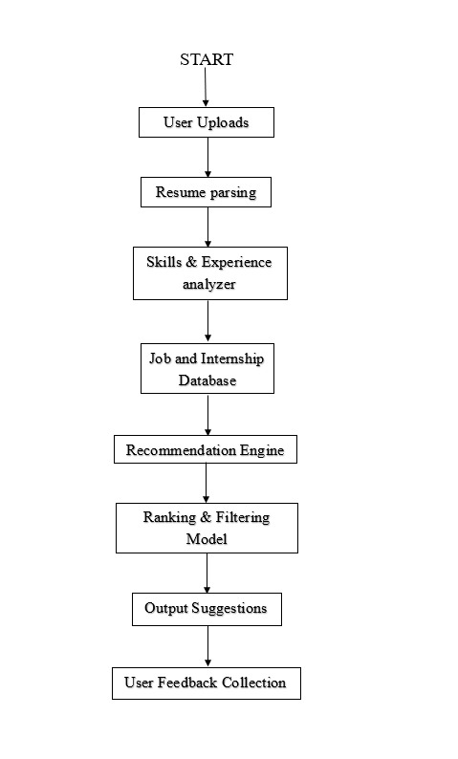

**SOFTWARE DESCRIPTION:**

**1. Name of the Software**

Resume Insight & Job Recommender (RIJR)

**2. Purpose and Functionality**

The software is a web application designed to help job seekers by analyzing their resumes and suggesting the best-fit internships and job opportunities based on their skills and experiences. It leverages Natural Language Processing (NLP) and data integration with job platforms (e.g., Internshala) to provide tailored recommendations.

**3. Key Features**

* **Resume Upload Portal**: Users can upload their resumes in formats such as PDF and DOCX.
* **Text Analysis and Skill Extraction**: Utilizes NLP techniques to extract and identify key skills, qualifications, and work experiences.
* **Internship and Job Recommendation**:
  + Suggests relevant internships from Internshala based on user profiles.
  + Recommends suitable jobs based on skills, experience, and industry trends.
* **User Dashboard**: A personalized interface displaying recommended internships and job opportunities, with relevant details and application links.
* **Feedback Mechanism**: Allows users to provide feedback on the relevance of recommendations for continuous improvement.

**4. Technology Stack**

* **Frontend**:
  + **Framework**: React.js or Angular for a responsive and interactive user interface.
  + **Design Tools**: HTML, CSS, and Bootstrap for UI/UX enhancements.
* **Backend**:
  + **Web Framework**: Flask or Django for handling resume uploads, data processing, and API interactions.
  + **Programming Language**: Python, due to its robust libraries for NLP and data processing.
* **NLP Libraries**:
  + **spaCy**: For named entity recognition and text processing.
  + **NLTK**: For additional text processing and linguistic analysis.
  + **TF-IDF and Scikit-learn**: For keyword extraction and matching algorithms.
* **Database**:
  + **Database Management**: MongoDB or PostgreSQL for storing user data and application logs.
* **APIs and Data Integration**:
  + Integration with job platforms like Internshala via API (if available) or through web scraping (with appropriate permissions).
* **Deployment Platforms**:
  + **Cloud Services**: AWS, Heroku, or Azure for hosting the web app and ensuring scalability.

**5. Core Functional Modules**

* **Resume Parser Module**:
  + Extracts text from uploaded documents using PyPDF2 or python-docx.
  + Cleans and normalizes text for consistent data extraction.
* **NLP Processing Module**:
  + Identifies skills, experiences, and education using NLP libraries.
  + Matches extracted data against a skill-job mapping database.
* **Recommendation Engine**:
  + Compares user profiles with job descriptions to calculate a matching score.
  + Uses rule-based and/or machine learning models to provide recommendations.
* **User Interaction Module**:
  + Enables users to interact with the system, upload resumes, and view recommendations through a streamlined UI.
* **Feedback Collection Module**:
  + Gathers user input to refine the recommendation logic over time.

**6. Benefits**

* **Personalized Experience**: Users receive customized recommendations tailored to their unique qualifications.
* **Time Efficiency**: Automates the job search process, saving users the time required to sift through numerous listings.
* **Accessibility**: Provides a simple, user-friendly interface that requires minimal technical knowledge to use.

**7. Security and Data Privacy**

* **Data Protection**: User resumes and personal data are stored securely with encryption.
* **Privacy Compliance**: The software follows data protection regulations, such as GDPR, ensuring user information is not shared without consent.

**8. Challenges Addressed**

* **Handling Varied Resume Formats**: The software incorporates advanced text extraction and NLP to manage different document types.
* **Real-Time Data Fetching**: Uses scheduled API calls or scraping scripts to maintain up-to-date job listings.

**OUTPUT:**

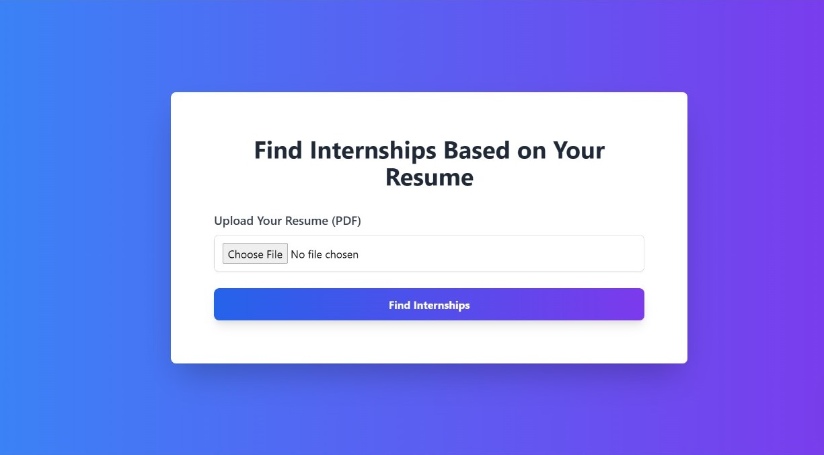

**Fig .1 . Web page for getting the input resume**

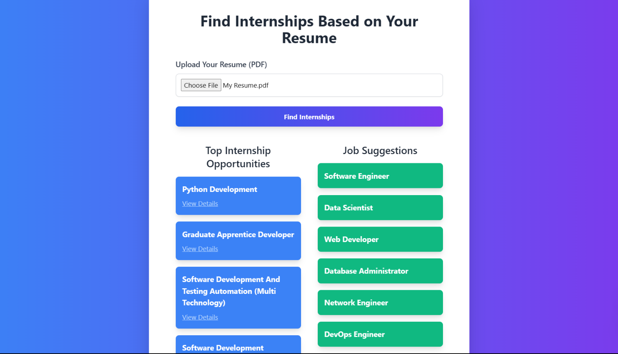

**Fig.2. Suggest internships and Job Suggestions**

**CONCLUSION:**

This internship and job recommendation system has shown the potential that NLP-based applications can be applied to make suggestions based on the skills and experiences of users. It has simplified the process of finding jobs by doing accurate analysis of resumes, matching the resume holders with relevant opportunities, especially those targeting students and recent graduates.

Future work would include improvement on the basis of providing a larger platform for more varied job sources than Internshala, and building upon advanced NLP models for better matches, personalized guidance for users related to their career. Continuous updates and user feedback would further enhance recommendation accuracy, adding additional value to this application as a career developer.

**REFERENCES:**

* 1. K Thangaramya, G Logeswari, Sudhakaran Gajendran, J Deepika Roselind, Neha Ahirwar (02 July 2024). Automated Resume Parsing and Ranking using Natural Language Processing. This Article has been accepted for Publication in IEEE.
  2. Anish Kulkarni, Om Kenge, Rohit Mehatre, Rucha Kulkarni (2024-02-19). Advancing Job Search: A Comprehensive Resume-Based Job Recommendation System Using NLP and Deep Learning Techniques. International journal for Research in Applied Science and Engineering Technology.
  3. Kevin Appadoo; Muhammad Bilaal Soonnoo; Zahra Mungloo-Dilmohamud (28 April 2021). job Recommendation System, Machine Learning, Regression, Classification, Natural Language Processing. This Article has been accepted for Publication in IEEE.
  4. B. Leela Prasad; K. Srividya; K. Nikhil Kumar; L. Kiran Chandra; N. S.S.K Dil; G. Vamsi Krishna (06 December 2023). An Advanced Real-Time Job Recommendation System and Resume Analyser. This Article has been accepted for Publication in IEEE.
  5. Ashish Virendra Chandak; Hardik Pandey; Gourav Rushiya; Harsh Sharma (01 April 2024). Resume Parser and Job Recommendation System using Machine Learning. This Article has been accepted for Publication in IEEE.